ENCHUFE N2288BL | 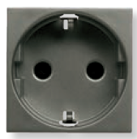 |  | ENCHUFE N2288BL
CONMUTADOR2M N2201BL | 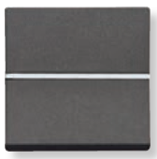 |  | CONMUTADOR2M N2201BL
CONMUTADOR1M  N2101BL | 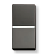 |  | CONMUTADOR1M  N2101BL
CRUZAMIENTO  N2210BL | 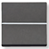 |  | CRUZAMIENTO  N2210BL
PULSADOR  N2204.6BL |  |  | PULSADOR  N2204.6BL
CARATULA TV  N2250.1BL | 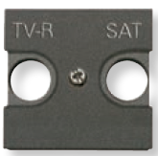 |  | CARATULA TV  N2250.1BL
TAPA 1SOPORTE  N2218.1BL | 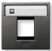 |  | TAPA 1SOPORTE  N2218.1BL
TAPA 2SOPORTE  N2218.2BL | 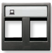 |  | TAPA 2SOPORTE  N2218.2BL
SOP. KEYSTONE  2018 | 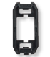 |  | SOP. KEYSTONE  2018
TAPA CIEGA  N2200BL | 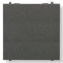 |  | TAPA CIEGA  N2200BL
TAPA CIEGA  N2100BL | 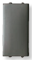 |  | TAPA CIEGA  N2100BL
BASTIDOR  N2271.9 | 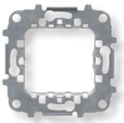 |  | BASTIDOR  N2271.9
PLACA 2M  N2271.1BL |  |  | PLACA 2M  N2271
PLACA 2V.2M  N2272.1BL |  |  | PLACA 2C.2M  N2272
PLACA 3V.2M  N2273.1BL |  |  | PLACA 3C.2M  N2273

